**Azure DevOps 2025**

**Introduction 🡪**

Azure DevOps is a cloud-based platform by Microsoft that provides development collaboration tools, including version control, build automation, release management, and more. It enables teams to plan, develop, test, and deploy applications efficiently.

**Key Components of Azure DevOps**

1. **Azure Repos**
   * Provides Git repositories for version control
   * Supports pull requests and branch policies
   * Enables code collaboration and tracking
2. **Azure Pipelines**
   * Automates build and release processes
   * Supports CI/CD (Continuous Integration/Continuous Deployment)
   * Compatible with multiple programming languages and platforms
3. **Azure Boards**
   * Agile project management tool
   * Offers Kanban boards, backlogs, and sprint planning
   * Provides tracking and reporting for work items
4. **Azure Test Plans**
   * Manages and executes test cases
   * Supports manual and automated testing
   * Ensures quality assurance through various test suites
5. **Azure Artifacts**
   * Manages and shares packages (e.g., NuGet, npm, Maven)
   * Helps maintain dependencies and versioning
   * Enables secure package storage

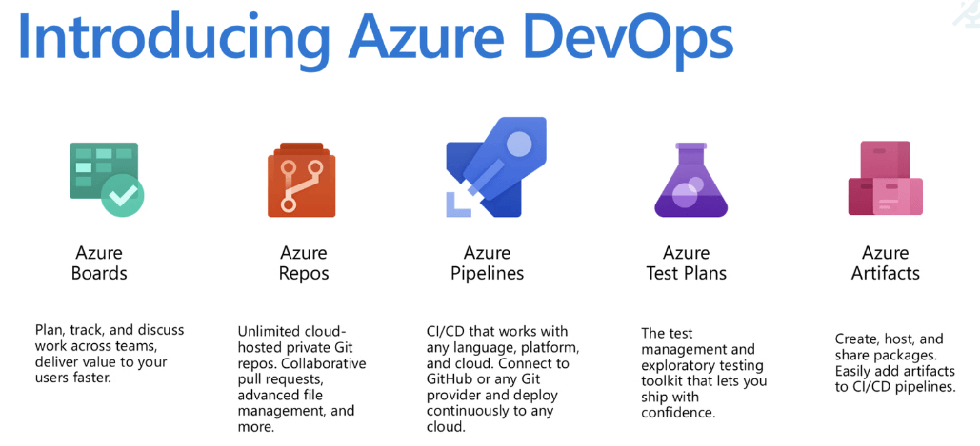

**Features of Azure DevOps**

* **Scalability**: Supports projects of any size
* **Integration**: Works with third-party tools like Jenkins, GitHub, etc.
* **Security**: Role-based access control and compliance management
* **Cloud and On-Premises**: Available as a cloud service and as Azure DevOps Server

**Azure DevOps Workflow**

1. **Plan**
   * Use Azure Boards for work tracking
   * Define tasks, user stories, and sprints
2. **Develop**
   * Use Azure Repos for version control
   * Implement code reviews and branch policies
3. **Build & Test**
   * Automate builds using Azure Pipelines
   * Run automated and manual tests with Azure Test Plans
4. **Release & Deploy**
   * Deploy applications using Azure Pipelines
   * Utilize release management for continuous delivery
5. **Monitor & Improve**
   * Track performance and issues with monitoring tools
   * Implement feedback loops for continuous improvement

**Azure DevOps Architecture**

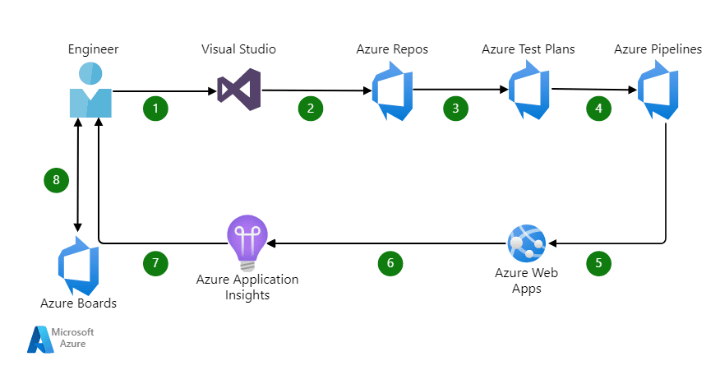

**Benefits of Using Azure DevOps**

* **End-to-end DevOps solution** with seamless integration
* **Faster development cycles** through automation
* **Enhanced collaboration** among teams
* **Improved security and compliance**
* **Flexible deployment options** (cloud, on-premises, hybrid)

**Getting Started with Azure DevOps**

1. **Create an Azure DevOps account** at [Azure DevOps](https://dev.azure.com/)
2. **Set up an organization and project**
3. **Configure repositories, pipelines, and work items**
4. **Collaborate with team members**
5. **Deploy applications and monitor performance**

**Conclusion**

Azure DevOps is a powerful and flexible platform that streamlines software development and deployment. It enhances collaboration, automates workflows, and ensures high-quality software delivery with its integrated tools.

# THREE-TIER ARCHITECTURE

## Introduction

Three-tier architecture is a software design pattern that separates an application into three logical and physical layers: **Presentation Layer**, **Business Logic Layer**, and **Data Layer**. This architecture enhances scalability, maintainability, and flexibility in application development.

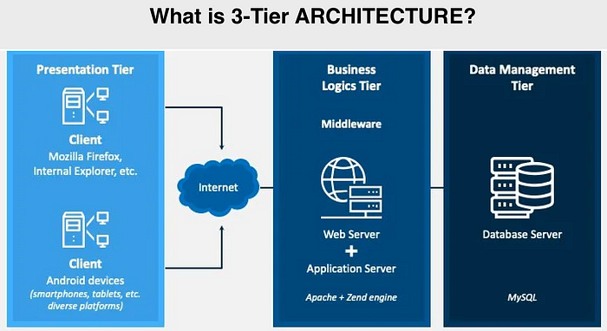

## ****Components of Three-Tier Architecture****

### 1. **Presentation Layer (User Interface Layer)-** Frontend

* This is the topmost layer that interacts with users.
* It consists of graphical user interfaces (GUIs) like web pages, mobile apps, or desktop applications.
* Responsible for collecting user inputs and displaying outputs.
* Example Technologies: HTML, CSS, JavaScript, React, Angular, Vue.js.

### 2. Business Logic Layer (Application Layer)- Backend

* This layer processes business logic and rules.
* Acts as a bridge between the Presentation and Data layers.
* Ensures proper validation, computation, and processing of user requests.
* Example Technologies: Java, .NET, Python, Node.js, PHP, Ruby on Rails.

### 3. Data Layer (Database Layer)- Database

* The bottom layer responsible for data storage and management.
* Handles database queries, transactions, and data integrity.
* Example Technologies: MySQL, PostgreSQL, MongoDB, Oracle, Microsoft SQL Server.

## ****Advantages of Three-Tier Architecture****

* **Scalability**: Each layer can be scaled independently.
* **Maintainability**: Easier debugging and updates.
* **Reusability**: Business logic can be reused across multiple applications.
* **Security**: Separation of concerns improves security.
* **Flexibility**: Different technologies can be used in each layer.

## ****Disadvantages of Three-Tier Architecture****

* **Complexity**: Requires more effort to design and maintain.
* **Latency**: Communication between layers may add processing delays.
* **Deployment Overhead**: More infrastructure is required for each layer.

## ****Use Cases of Three-Tier Architecture****

* **Web Applications**: E-commerce, social media, content management systems.
* **Enterprise Applications**: ERP, CRM, banking software.
* **Mobile Applications**: Backend for mobile apps.
* **Cloud-Based Solutions**: SaaS, PaaS applications.

## ****Conclusion****

Three-tier architecture is widely used in modern application development due to its modularity, flexibility, and maintainability. Despite some challenges, it remains a preferred choice for scalable and secure applications.

### **GUI (Graphical User Interface) Mode**

* GUI provides a visual interface with graphical elements like windows, buttons, icons, and menus.
* It allows users to interact with the system using a mouse, touchscreen, or keyboard.
* Easier to use, especially for beginners.
* Examples:
  + Windows, macOS, Linux (Ubuntu’s GNOME, KDE)
  + Software like Microsoft Word, Photoshop, and web browsers.

### **CUI (CHARACTER USER INTERFACE) MODE**

* CUI (also called CLI – Command Line Interface) is text-based, where users interact with the system by typing commands.
* Requires knowledge of specific commands.
* More efficient for experienced users and automation tasks.
* Examples:
* Command Prompt (cmd) in Windows
* Terminal in Linux/macOS
* PowerShell, Bash, and SSH

Let’s compare **GUI vs. CUI** with a real-world example: **Creating a Folder**

### **1. USING GUI (GRAPHICAL USER INTERFACE)**

* **Steps:**
  1. Open "File Explorer" (Windows) or "Finder" (Mac).
  2. Navigate to the location where you want to create the folder.
  3. Right-click → Select **New → Folder**.
  4. Enter a name for the folder and press **Enter**.

✅ **Easy, visual, and beginner-friendly!**

### **2. Using CUI (Command Line Interface)**

* **Steps (Windows CMD/PowerShell or Linux Terminal):**
  1. Open **Command Prompt (cmd)** in Windows or **Terminal** in Linux/macOS.
  2. Navigate to the location:
     + **Windows:** cd C:\Users\YourName\Documents
     + **Linux/macOS:** cd /home/yourname/Documents
  3. Create a folder:
     + **Windows:** Right click and New Folder MyFolder
     + **Linux/macOS:** mkdir MyFolder
  4. Press **Enter**, and the folder is created!

✅ **Faster and useful for automation but requires knowledge of commands.**

### **Comparison Table:**

| **Feature** | **GUI** | **CUI** |
| --- | --- | --- |
| **Ease of Use** | Easy (Click & Drag) | Harder (Requires Commands) |
| **Speed** | Slower for repetitive tasks | Faster for automation |
| **Flexibility** | Limited to UI options | Highly flexible |
| **Memory Usage** | Higher | Lower |
| **Best For** | Beginners, General Users | Developers, System Admins |

## ****Linux: An Overview****

Linux is a **free and open-source operating system (OS)** based on the Unix operating system. It is widely used in servers, desktops, embedded systems, and supercomputers. Linux is known for its **stability, security, and flexibility**, making it popular among developers, enterprises, and individual users.

### **Key Features of Linux:**

1. **Open Source** – The source code is freely available for anyone to modify and distribute.
2. **Multi-User** – Multiple users can use the system simultaneously.
3. **Multi-Tasking** – Capable of handling multiple processes at once.
4. **Security** – Uses permissions, encryption, and firewall features for security.
5. **Portability** – Runs on a variety of hardware, from PCs to embedded devices.
6. **File System Support** – Supports various file systems like ext4, XFS, Btrfs, and NTFS.
7. **Shell and Command Line Interface (CLI)** – Users can interact with the system using powerful shell commands.

## ****History of Linux****

### **1. Origins: UNIX and Minix (1969–1990)**

* **UNIX (1969)**: Developed at AT&T’s Bell Labs by **Ken Thompson and Dennis Ritchie**, UNIX became the foundation for many future OS.
* **Minix (1987)**: A Unix-like OS created by **Andrew S. Tanenbaum** for educational purposes. It inspired the development of Linux.

### **2. Birth of Linux (1991)**

* In **1991, Linus Torvalds**, a Finnish computer science student, started developing Linux as a personal project.
* He wanted to create a **free, open-source operating system** similar to Minix but with improved features.
* On **August 25, 1991**, Torvalds announced the first version of Linux in an online forum.
* The first Linux **kernel (version 0.01)** was released in **September 1991**.

### **3. Growth and Development (1992–1999)**

* **GNU/Linux (1992)**: The Linux kernel combined with **GNU software tools** (from the Free Software Foundation) formed a complete operating system.
* **Distributions (1993)**: Early Linux distributions like Slackware and Debian were created.
* **Enterprise Adoption (Late 1990s)**: Companies like IBM and Red Hat started supporting Linux, leading to its widespread use in servers.

### **4. Modern Linux (2000–Present)**

* **Rise of Ubuntu (2004)**: Ubuntu made Linux more user-friendly for desktops.
* **Android (2008)**: Google built Android on the Linux kernel, making Linux the backbone of mobile devices.
* **Cloud Computing & IoT**: Linux dominates cloud servers and IoT (Internet of Things) devices.
* **Supercomputers & AI**: Most supercomputers and AI systems use Linux due to its performance and flexibility.

### **Difference Between Linux and Operating System**

| **Feature** | **Linux** | **Operating System (OS)** |
| --- | --- | --- |
| **Definition** | Linux is a **kernel**, the core component of an OS that manages hardware and system resources. | An OS is a complete software system that includes the kernel, user interface, and utilities for managing hardware and software. |
| **Type** | It is a **Unix-like, open-source kernel**. | OS can be **Windows, macOS, Linux (various distributions), Android, etc.** |
| **Scope** | Linux alone is not a full OS; it needs additional components (like GNU tools) to function as one. | The OS includes the **kernel, shell, file system, drivers, and applications**. |
| **Examples** | Linux distributions: **Ubuntu, Debian, Fedora, Arch Linux, Red Hat**. | OS types: **Windows, macOS, Android, iOS, Linux distributions**. |
| **Development** | Created by **Linus Torvalds** in 1991. | Various OS are developed by different companies: **Microsoft (Windows), Apple (macOS), Google (Android), Linux community (Linux distributions)**. |
| **Usage** | Used mainly in **servers, embedded systems, supercomputers, and mobile devices**. | OS is used in **desktops, laptops, mobile phones, tablets, and servers**. |

### **Conclusion**

* **Linux is a kernel,** whereas an **Operating System is a complete software package** that includes a kernel and user utilities.
* **Linux-based OS** (like Ubuntu, Fedora) use the Linux kernel along with additional software components to provide a complete system.

## ****Prompt Engineering: A Detailed Overview****

#### What is Prompt Engineering?

**Prompt engineering** is the practice of designing and optimizing prompts to effectively interact with **AI models** like ChatGPT, Bard, and Claude. It involves crafting precise and structured **instructions, questions, or inputs** to get the most accurate and useful responses from an AI system.

## ***Why is Prompt Engineering Important?***

1. **Enhances AI Responses** – Well-crafted prompts lead to more relevant and accurate outputs.
2. **Optimizes AI Efficiency** – Reduces the need for multiple iterations to get the desired answer.
3. **Customizes AI Behavior –** Allows users to shape responses for specific use cases like coding, writing, or data analysis.
4. **Boosts Productivity –** Helps professionals automate tasks, generate creative content, and improve decision-making.

## ****Key Techniques in Prompt Engineering****

### **1. Clear and Specific Instructions**

* Example:
  + ❌ "Tell me about cars." (Too vague)
  + ✅ "Provide a comparison of electric and gasoline cars based on cost, efficiency, and environmental impact." (Specific)

### **2. Using Role Assignments**

* Example:
  + **"You are a cybersecurity expert. Explain how firewalls protect a network from cyber threats."**

### **3. Providing Context**

* Example:
  + **"In the context of digital marketing, explain how SEO works and its impact on website traffic."**

### **4. Step-by-Step Instructions**

* Example:
  + **"List the steps to install Python on Windows and configure a virtual environment."**

### **5. Using Examples for Clarity**

* Example:
  + **"Explain recursion in programming with an example in Python."**

### **6. Setting Output Format**

* Example:
  + **"Generate a table comparing Linux distributions, including Ubuntu, Fedora, and Arch Linux, based on ease of use, stability, and customization."**

## ****Applications of Prompt Engineering****

1. **Chatbots & Virtual Assistants** – Designing prompts to improve AI-powered customer service.
2. **Content Generation –** Creating engaging blogs, stories, and articles using AI.
3. **Coding Assistance** – Generating, debugging, and explaining code snippets.
4. **Education & Learning** – Helping students and teachers with AI-powered explanations.
5. **Data Analysis** – Extracting insights from complex datasets using structured prompts.

## ****Future of Prompt Engineering****

As AI models advance, prompt engineering will become an essential skill in fields like **AI development, automation, and human-computer interaction**. Future AI systems may require less manual prompt tuning, but **understanding how to communicate effectively with AI will remain valuable**.

## ****Windows Subsystem for Linux (WSL) - Overview****

### **What is WSL?**

Windows Subsystem for Linux (WSL) is a **compatibility layer** that allows users to run a **Linux environment natively** on Windows **without using a virtual machine or dual-boot setup**. It enables developers to use Linux command-line tools, utilities, and applications directly on Windows.

## ****History and Development****

* **WSL 1 (2016)**: Introduced in Windows 10, it translated Linux system calls into Windows equivalents but had limitations in performance and compatibility.
* **WSL 2 (2019)**: Uses a **real Linux kernel** via virtualization, improving performance, system call compatibility, and support for Docker and GUI applications.
* **WSL on Windows 11 (2021)**: Improved with GUI support, GPU acceleration, and automatic updates via the Microsoft Store.

## ****Key Features of WSL****

1. **Native Linux on Windows** – No need for a separate Linux installation.
2. **Fast Performance** – WSL 2 offers near-native performance using a lightweight virtual machine.
3. **Full Linux Compatibility** – Runs real Linux binaries with full system call support.
4. **File System Integration** – Access Windows files from Linux (/mnt/c/) and vice versa.
5. **Support for Multiple Distros** – Install and run Ubuntu, Debian, Kali Linux, Fedora, etc.
6. **Docker Support** – WSL 2 works with Docker for running containers on Windows.
7. **GUI Applications Support** – Run Linux graphical apps directly on Windows 11.

## ****Installing WSL****

### **Step 1: Enable WSL**

Open PowerShell as Administrator and run:

**powershell**

**CopyEdit**

**wsl --install**

This installs WSL with the default Ubuntu distribution.

### **Step 2: Set a Default Distribution (Optional)**

powershell

CopyEdit

wsl --set-default <DistroName>

Example:

powershell

CopyEdit

wsl --set-default Ubuntu

### **Step 3: Launch WSL**

powershell

CopyEdit

wsl

This opens the Linux terminal inside Windows.

## ****Comparison: WSL 1 vs WSL 2****

| **Feature** | **WSL 1** | **WSL 2** |
| --- | --- | --- |
| **Architecture** | Translates Linux system calls to Windows | Uses a real Linux kernel with a lightweight VM |
| **Performance** | Faster for file system operations | Better for system calls and app compatibility |
| **Full Linux Kernel** | No | Yes |
| **Docker Support** | Limited | Full support |
| **GUI App Support** | No | Yes (Windows 11) |

## ****Use Cases of WSL****

1. **Software Development** – Run Linux-based tools like Git, Vim, and programming languages (Python, Node.js, etc.).
2. **System Administration –** Use Bash scripting, SSH, and Linux commands on Windows.
3. **Web Development** – Develop and test applications in a Linux environment.
4. **Cybersecurity –** Run Kali Linux tools for penetration testing.
5. **Machine Learning & AI** – Leverage Linux-based ML frameworks like TensorFlow and PyTorch.

## ****Conclusion****

WSL provides **the best of both worlds**—Linux development tools on Windows without the overhead of a virtual machine. With **WSL 2**, users get **better performance, full Linux compatibility, and GUI support**.

**🚀 Top 100 Linux Commands You Should Know! 🖥️🌟**

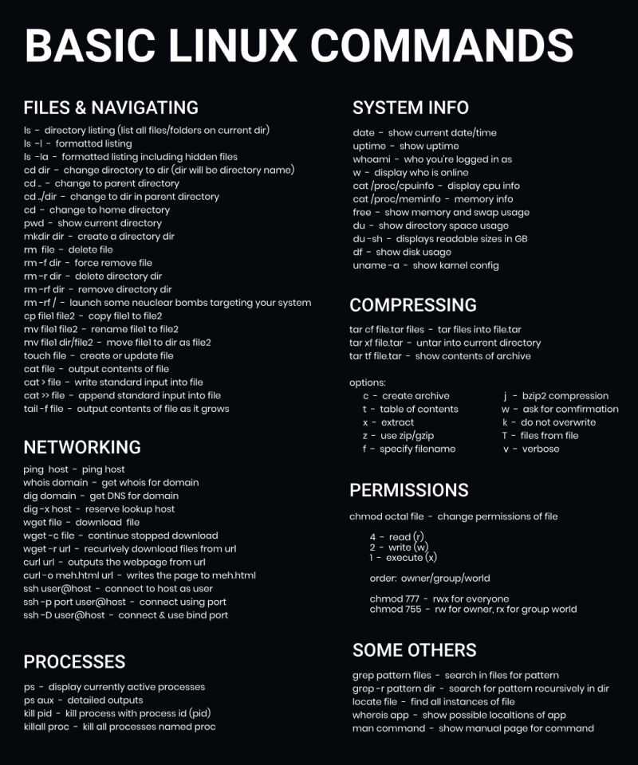

## 🚀 ****Top 100 Linux Commands You Should Know!**** 🖥️🌟

Linux is powerful, and mastering its commands boosts productivity! Below is a categorized list of **100 essential Linux commands** every user should know.

### **🏗 1. Basic Commands**

| **Command** | **Description** |
| --- | --- |
| **pwd** | Print working directory (shows current location) |
| **ls** | List files in a directory |
| **cd** | Change directory |
| **mkdir** | Create a new directory |
| **rmdir** | Remove an empty directory |
| **rm -r** | Remove a directory and its contents |
| **touch** | Create an empty file |
| **cp file1 file2** | Copy a file |
| **mv file1 file2** | Move or rename a file |
| **rm file** | Delete a file |

### **📄 2. File & Directory Management**

| **Command** | **Description** |
| --- | --- |
| **find /path -name file.txt** | Search for a file by name |
| **locate file.txt** | Locate a file (requires updatedb first) |
| **updatedb** | Update file database for locate |
| **stat file.txt** | Show detailed file information |
| **ls -lh** | List files with human-readable sizes |
| **tree** | Show directories as a tree (install if needed) |
| **basename /path/file.txt** | Extract filename from a path |
| **dirname /path/file.txt** | Extract directory name from a path |

### **🔍 3. Viewing & Editing Files**

| **Command** | **Description** |
| --- | --- |
| **cat file.txt** | Display file contents |
| **tac file.txt** | Display file contents in reverse |
| **less file.txt** | View file contents page by page |
| **more file.txt** | View file contents page by page (less advanced) |
| **head -n 10 file.txt** | Show first 10 lines of a file |
| **tail -n 10 file.txt** | Show last 10 lines of a file |
| **tail -f file.txt** | Show live updates of a file (useful for logs) |
| **nano file.txt** | Edit a file with Nano |
| **vim file.txt** | Edit a file with Vim |
| **vi file.txt** | Edit a file with Vi |

### **🔑 4. File Permissions & Ownership**

| **Command** | **Description** |
| --- | --- |
| **ls -l** | Show file permissions |
| **chmod 777 file.txt** | Give full permissions to a file |
| **chmod +x script.sh** | Make a script executable |
| **chown user:group file.txt** | Change file owner and group |
| **chgrp group file.txt** | Change file group ownership |
| **umask** | Show default file permissions |

### **🖥 5. Process Management**

| **Command** | **Description** |
| --- | --- |
| **ps aux** | Show running processes |
| **top** | Display active processes dynamically |
| **htop** | Interactive process viewer (requires install) |
| **kill PID** | Terminate a process by its ID |
| **killall process-name** | Kill all instances of a process |
| **pkill -9 process-name** | Kill a process by name |
| **bg** | Resume a job in the background |
| **fg** | Resume a job in the foreground |
| **jobs** | List background jobs |

### **🌐 6. Networking**

| **Command** | **Description** |
| --- | --- |
| **ping google.com** | Test network connectivity |
| **ifconfig** | Show network interface details |
| **ip a** | Show IP addresses (alternative to ifconfig) |
| **netstat -tulnp** | Display active network connections |
| **ss -tulnp** | Modern alternative to netstat |
| **wget URL** | Download a file from the web |
| **curl URL** | Fetch data from a URL |
| **nslookup domain.com** | Get DNS information for a domain |
| **traceroute google.com** | Show the path packets take to a host |
| **hostname -I** | Show system’s IP address |

### **🔥 7. User Management**

| **Command** | **Description** |
| --- | --- |
| **whoami** | Show current logged-in user |
| **who** | Show logged-in users |
| **id username** | Show user and group IDs |
| **adduser username** | Create a new user |
| **passwd username** | Change a user's password |
| **deluser username** | Remove a user |
| **usermod -aG group username** | Add a user to a group |
| **groups username** | Show groups a user belongs to |

### **⚙ 8. System Monitoring & Info**

| **Command** | **Description** |
| --- | --- |
| **uname -a** | Show system information |
| **uptime** | Show system uptime |
| **df -h** | Show disk usage |
| **du -sh folder/** | Show folder size |
| **free -m** | Show memory usage |
| **vmstat** | Show system performance stats |
| **iostat** | Show CPU and disk usage (install sysstat) |
| **uptime** | Show how long the system has been running |

### **📦 9. Package Management**

| **Command** | **Description** |
| --- | --- |
| **apt update** | Update package list (Debian/Ubuntu) |
| **apt upgrade** | Upgrade installed packages |
| **apt install package** | Install a package |
| **apt remove package** | Uninstall a package |
| **yum install package** | Install a package (RHEL/CentOS) |
| **dnf install package** | Install package (Fedora) |
| **snap install package** | Install a package via Snap |
| **flatpak install package** | Install a package via Flatpak |

### **🔄 10. Compression & Archiving**

| **Command** | **Description** |
| --- | --- |
| **tar -cvf archive.tar folder/** | Create a tar archive |
| **tar -xvf archive.tar** | Extract a tar archive |
| **tar -czvf archive.tar.gz folder/** | Create a compressed tar archive |
| **tar -xzvf archive.tar.gz** | Extract a compressed tar archive |
| **zip archive.zip file.txt** | Create a zip file |
| **unzip archive.zip** | Extract a zip file |
| **gzip file.txt** | Compress a file with Gzip |
| **gunzip file.txt.gz** | Decompress a Gzip file |

### **🔄 11. System Shutdown & Reboot**

| **Command** | **Description** |
| --- | --- |
| **shutdown -h now** | Shutdown system immediately |
| **shutdown -r now** | Reboot system immediately |
| **reboot** | Restart the system |
| **halt** | Stop the system |

## 🎯 ****Conclusion****

Mastering these Linux commands will make you a pro at navigating, managing, and optimizing Linux systems! 🚀 Whether you're a beginner or an advanced user, these commands will **boost your efficiency and control over Linux.**

### **🌍 Linux File System 🌍**

The Linux file system might seem chaotic at first, but it's highly organized and efficient once you understand its structure. Here's a breakdown of the key components of the Linux file system, often referred to as the **Filesystem Hierarchy Standard (FHS)**:

### 🌍 **The Root Directory** /

The top-most directory in the Linux file system is / (known as the root directory). All other directories and files branch out from here.

### 📂 **Key Directories in Linux File System**

1. **/bin (Binary)**
   * Contains essential command binaries or executable files that are required for the system to operate, like ls, cp, mv, etc.
2. **/boot**
   * Stores boot loader files, such as the Linux kernel (vmlinuz), and initial RAM disk (initrd), which are required for system startup.
3. **/dev (Device)**
   * Houses device files that represent hardware devices like disks, input/output devices, and more. For example, /dev/sda represents the first hard drive.
4. **/etc**
   * Contains system configuration files for the operating system and installed software. Key files include /etc/fstab (file systems), /etc/passwd (user information), and /etc/network/ (network settings).
5. **/home**
   * The directory where users' personal files and directories are stored. For example, /home/username/ would be the directory for a specific user's data.
6. **/lib (Libraries)**
   * Contains essential shared libraries and kernel modules needed by the programs in /bin and /sbin.
7. **/media**
   * Temporary mount point for removable devices like USB drives, CD/DVDs, etc.
8. **/mnt**
   * A mount point for temporarily mounted file systems. It’s often used for manually mounting devices or partitions.
9. **/opt (Optional)**
   * Used to store optional software and third-party applications. For example, software packages installed via installers outside the OS package manager can go here.
10. **/proc (Process)**
    * A virtual file system that provides process and system information. Files like /proc/cpuinfo and /proc/meminfo contain details about the CPU and memory.
11. **/root**
    * The home directory for the system administrator (root user).
12. **/run**
    * Contains runtime data for the system and processes, such as PID files, locks, etc.
13. **/sbin (System Binary)**
    * Contains system administration commands that are used for maintenance and troubleshooting, usually by the root user.
14. **/srv**
    * Stores data for services provided by the system (like web servers or FTP servers).
15. **/sys**
    * A virtual file system that provides information about devices, kernel modules, and other kernel-related information.
16. **/tmp**
    * Stores temporary files created by programs during their operation. Files here are often automatically deleted after a reboot.
17. **/usr**
    * Contains user-related programs, libraries, and documentation. It's the largest directory and is used for software that is not essential for the system to operate but is still necessary for user applications.
    * Subdirectories:
      + /usr/bin: Non-essential user binaries.
      + /usr/lib: Libraries for programs in /usr/bin.
      + /usr/share: Architecture-independent files like documentation.
18. **/var (Variable)**
    * Stores variable files like logs (/var/log/), mail, spool directories, and other files that need to be updated frequently.

### 🧭 **How Does It All Work Together?**

* **Filesystem Hierarchy**: The Linux file system is hierarchical, with directories branching off the root (/) and storing system files, user files, temporary files, etc.
* **Mounting**: Different partitions, filesystems, or devices (e.g., USB drives, external HDDs) can be mounted to any of these directories, often under /mnt or /media.
* **Permissions**: Each file and directory has its own permissions, controlling who can read, write, or execute them.

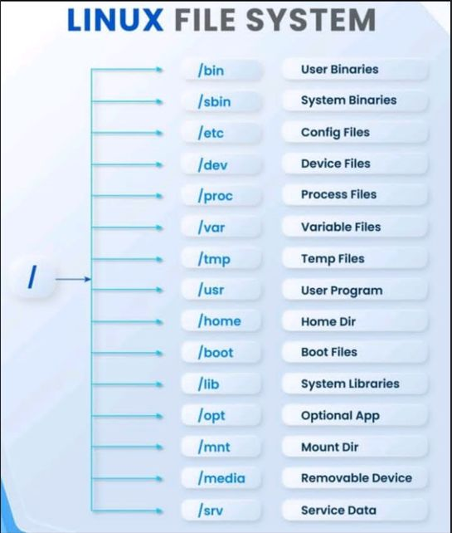

### 🌍 **Absolute Path &** 🔄 **Relative Path in Linux**

In Linux, **file paths** are used to specify the location of a file or directory in the filesystem. There are two types of paths that you’ll commonly encounter:

### 🌍 **Absolute Path**

An **absolute path** is a complete path that begins from the root directory /. It specifies the exact location of a file or directory in the filesystem, no matter where you are in the system.

* **Starts with / (root)**: The absolute path always begins from the root directory.
* **Full directory structure**: It contains the entire path leading to the file or directory, following the hierarchical structure.

#### Example:

bash

CopyEdit

/home/user/Documents/file.txt

This path specifies that:

* file.txt is in the Documents directory,
* The Documents directory is in the user home directory,
* The user directory is located under the home directory,
* The root directory / is the starting point.

#### Advantages of Absolute Path:

* Always points to the same location, no matter the current working directory.
* Makes it easy to reference files and directories from anywhere in the system.

### 🔄 **Relative Path**

A **relative path** specifies the location of a file or directory **relative** to the current working directory. It does not start from the root directory, but instead, it describes the path from where you are.

* **Starts from the current directory**: It is relative to the directory you’re currently in.
* **No / at the beginning**: The path doesn't start with a /, but instead is relative to your present location in the filesystem.

#### Example:

bash

CopyEdit

Documents/file.txt

This path specifies that:

* The file file.txt is inside the Documents directory.
* Documents is relative to the directory you're currently working in. If you're inside /home/user/, this path refers to /home/user/Documents/file.txt.

#### Special Symbols in Relative Paths:

* **./**: Refers to the current directory. For example, ./file.txt refers to file.txt in the current directory.
* **../**: Refers to the parent directory. For example, ../file.txt refers to file.txt located one level up from the current directory.

#### Example:

If you're currently in /home/user/:

* ./Documents/file.txt refers to /home/user/Documents/file.txt.
* ../file.txt refers to /home/file.txt.

#### Advantages of Relative Path:

* Shorter and more flexible for navigating within the same directory structure.
* Ideal for scripts and working within directories that don't require absolute locations.

### 🆚 **Key Differences Between Absolute and Relative Paths**

| **Feature** | **Absolute Path** | **Relative Path** |
| --- | --- | --- |
| **Starts with** | / (root directory) | Current directory (no / at the start) |
| **Reference** | Points to a specific location in the filesystem | Points to a location relative to the current directory |
| **Example** | /home/user/Documents/file.txt | Documents/file.txt |
| **Flexibility** | Fixed, regardless of the current directory | Changes depending on the current working directory |
| **Use Case** | Used when you need the exact location of a file or directory | Used for navigation and relative file locations within the same structure |

Understanding the difference between absolute and relative paths is crucial for effective navigation and file management in Linux.

**How to install software in Linux?**

Installing software on Linux can vary depending on the **distribution (distro)** you are using, as different distributions may use different package management systems. Here's a general guide on how to install software across various Linux distributions:

### 🖥️ **1. Using Package Managers (Most Common Method)**

#### A. **Debian-based Distros (e.g., Ubuntu, Linux Mint)**

**Package Manager**: apt (Advanced Package Tool)

1. **Update the package list**:

bash

CopyEdit

sudo apt update

1. **Install a package**:

bash

CopyEdit

sudo apt install <package-name>

Example:

bash

CopyEdit

sudo apt install vim

1. **Install a specific version of a package**:

bash

CopyEdit

sudo apt install <package-name>=<version-number>

Example:

bash

CopyEdit

sudo apt install vim=2:8.1.2269-1ubuntu5.4

1. **Upgrade all installed packages**:

bash

CopyEdit

sudo apt upgrade

1. **Remove a package**:

bash

CopyEdit

sudo apt remove <package-name>

#### B. **Red Hat-based Distros (e.g., RHEL, CentOS, Fedora)**

**Package Manager**: dnf (Fedora) / yum (RHEL/CentOS 7 and older)

1. **Update the package list** (Fedora):

bash

CopyEdit

sudo dnf update

(For older RHEL/CentOS versions):

bash

CopyEdit

sudo yum update

1. **Install a package** (Fedora):

bash

CopyEdit

sudo dnf install <package-name>

(For older RHEL/CentOS versions):

bash

CopyEdit

sudo yum install <package-name>

Example:

bash

CopyEdit

sudo dnf install vim

1. **Remove a package**:

bash

CopyEdit

sudo dnf remove <package-name>

(For older RHEL/CentOS versions):

bash

CopyEdit

sudo yum remove <package-name>

#### C. **Arch-based Distros (e.g., Arch Linux, Manjaro)**

**Package Manager**: pacman

1. **Update the package list and upgrade the system**:

bash

CopyEdit

sudo pacman -Syu

1. **Install a package**:

bash

CopyEdit

sudo pacman -S <package-name>

Example:

bash

CopyEdit

sudo pacman -S vim

1. **Remove a package**:

bash

CopyEdit

sudo pacman -R <package-name>

### 🛠️ **2. Using Snap (Universal Package Format)**

**Snap** is a universal package manager that works across different Linux distributions.

1. **Install Snap (if not already installed)**:
   * On Ubuntu-based distros, it's already installed.
   * On other distros:

bash

CopyEdit

sudo apt install snapd # Ubuntu

sudo dnf install snapd # Fedora

sudo pacman -S snapd # Arch

1. **Install a Snap package**:

bash

CopyEdit

sudo snap install <package-name>

Example:

bash

CopyEdit

sudo snap install spotify

1. **Remove a Snap package**:

bash

CopyEdit

sudo snap remove <package-name>

### 📦 **3. Using Flatpak (Another Universal Package Format)**

Flatpak is another universal package manager for Linux.

1. **Install Flatpak (if not already installed)**:
   * On Ubuntu-based distros:

bash

CopyEdit

sudo apt install flatpak

* + On Fedora:

bash

CopyEdit

sudo dnf install flatpak

* + On Arch Linux:

bash

CopyEdit

sudo pacman -S flatpak

1. **Add the Flathub repository** (to get most apps):

bash

CopyEdit

sudo flatpak remote-add --if-not-exists flathub https://flathub.org/repo/flathub.flatpakrepo

1. **Install a Flatpak package**:

bash

CopyEdit

sudo flatpak install flathub <package-name>

Example:

bash

CopyEdit

sudo flatpak install flathub com.spotify.Client

1. **Remove a Flatpak package**:

bash

CopyEdit

sudo flatpak uninstall <package-name>

### 💻 **4. Installing from Source (Advanced)**

Sometimes, the software you want isn’t available in your distro's repositories. In this case, you can **download the source code** and **compile** it yourself.

1. **Install build tools** (if not already installed):

bash

CopyEdit

sudo apt install build-essential # For Debian-based

sudo dnf groupinstall "Development Tools" # For Red Hat-based

sudo pacman -S base-devel # For Arch-based

1. **Download the software source code**:
   * From the official website or GitHub.
2. **Extract and navigate to the source directory**:

bash

CopyEdit

tar -xzvf software.tar.gz

cd software-directory

1. **Compile the software**:

bash

CopyEdit

./configure

make

sudo make install

### 🖥️ **5. Using a GUI (Graphical User Interface)**

* **Software Center** (for Ubuntu, Linux Mint, etc.) provides a graphical way to install software:
  + Open the **Software Center** (Ubuntu Software or Discover on KDE).
  + Search for the software you need.
  + Click **Install**.
* **GNOME Software** and **KDE Discover** are other examples of GUI-based software management tools.

### 🏁 **Summary**

* **Package Managers**: The easiest and most common method. Use apt, dnf, yum, or pacman depending on your distro.
* **Universal Package Managers**: Use Snap or Flatpak for software that can work across multiple distros.
* **Building from Source**: A more advanced method, useful if the software isn’t available in the repositories.
* **Graphical Tools**: Many distros provide graphical package managers for users who prefer a GUI.

The method you choose will depend on your system, preferences, and the software you need to install.

### **What is Cloud?** ☁️

The **cloud** refers to a network of remote servers that are hosted on the internet, rather than being stored on a local server or a personal computer. It allows users and businesses to store, manage, and process data, applications, and services online, making it accessible from anywhere with an internet connection. Cloud computing has revolutionized the way we use technology, enabling efficient data management and access to a wide variety of services.

### **Key Characteristics of Cloud Computing:**

1. **On-Demand Self-Service**:
   * Users can access and manage cloud resources (like storage, computing power, etc.) as needed without manual intervention.
2. **Broad Network Access**:
   * Cloud services can be accessed from any device (laptop, smartphone, tablet) with an internet connection.
3. **Resource Pooling**:
   * Cloud providers use multi-tenant models, pooling resources to serve multiple clients, which helps optimize resource utilization and reduce costs.
4. **Rapid Elasticity**:
   * Cloud services can be scaled up or down quickly and automatically based on demand, ensuring optimal resource usage.
5. **Measured Service**:
   * Resources are metered, and users pay only for what they use (pay-as-you-go model), which offers cost efficiency.

### **Types of Cloud Computing Models**:

1. **Public Cloud**:
   * Services are delivered over the public internet and shared across different organizations. Examples include **Amazon Web Services (AWS)**, **Google Cloud**, and **Microsoft Azure**.
   * **Advantages**: Cost-effective, scalable, no maintenance or hardware costs for the user.
2. **Private Cloud**:
   * A dedicated cloud infrastructure used by a single organization, often hosted on-premise or in a private data center.
   * **Advantages**: Increased security and control, better compliance with regulations.
3. **Hybrid Cloud**:
   * A mix of both public and private clouds, allowing data and applications to move between them. This approach provides flexibility and optimization of existing infrastructure.
   * **Advantages**: Scalability of public cloud with the security of private cloud.

### **Cloud Service Models**:

1. **Infrastructure as a Service (IaaS)**:
   * Provides virtualized computing resources over the internet (like virtual machines, storage, networks).
   * Examples: **Amazon EC2**, **Google Compute Engine**, **Microsoft Azure VMs**.
   * **Use Case**: Companies that need flexible, on-demand infrastructure.
2. **Platform as a Service (PaaS)**:
   * Offers hardware and software tools for developing applications, typically used for app development and deployment.
   * Examples: **Google App Engine**, **AWS Elastic Beanstalk**, **Microsoft Azure App Service**.
   * **Use Case**: Developers needing to build, test, and deploy applications without worrying about managing infrastructure.
3. **Software as a Service (SaaS)**:
   * Provides access to software applications through the internet, eliminating the need for installation and maintenance.
   * Examples: **Google Workspace (Docs, Gmail)**, **Microsoft 365**, **Salesforce**.
   * **Use Case**: Businesses that need ready-to-use software applications without worrying about updates or maintenance.

### **Benefits of Cloud Computing**:

1. **Cost Savings**:
   * No need to invest in physical hardware or maintain infrastructure. Pay only for what you use.
2. **Scalability**:
   * Easily scale resources up or down as needed based on demand, making it suitable for growing businesses.
3. **Access from Anywhere**:
   * Access data, applications, and services from any device, at any time, and from anywhere with an internet connection.
4. **Security**:
   * Cloud providers invest heavily in security, including encryption, firewalls, and access controls, to ensure the safety of data.
5. **Automatic Updates and Maintenance**:
   * Cloud services are continuously updated with the latest features, security patches, and bug fixes, reducing the burden on users.
6. **Disaster Recovery**:
   * Cloud computing can back up data, ensuring business continuity in the event of a disaster (like server failure or data loss).

### **Popular Cloud Providers**:

1. **Amazon Web Services (AWS)**:
   * Offers a wide range of services, from computing power to machine learning, database storage, and more.
2. **Google Cloud**:
   * Known for its strength in data analytics, machine learning, and scalability.
3. **Microsoft Azure**:
   * Popular among enterprises, offering cloud services integrated with Microsoft products like Windows Server, SQL Server, and Office 365.
4. **IBM Cloud**:
   * Known for its focus on AI, IoT, and enterprise-level services.
5. **Oracle Cloud**:
   * Strong in database services and enterprise resource planning (ERP).

### **Cloud Computing Use Cases**:

1. **Data Storage & Backup**:
   * Cloud services are widely used for backing up data and offering scalable storage solutions.
2. **Web Hosting**:
   * Hosting websites and applications in the cloud, which ensures fast scalability and availability.
3. **Collaborative Tools**:
   * Cloud-based tools like Google Drive, Dropbox, and Microsoft OneDrive allow users to store, share, and collaborate on documents from anywhere.
4. **Big Data & Analytics**:
   * Cloud providers offer specialized services for processing and analyzing massive datasets using tools like AWS Redshift, Google BigQuery, etc.
5. **Disaster Recovery and Business Continuity**:
   * Cloud allows businesses to store backups of critical data and applications, ensuring that operations can continue even after an outage.

### **Challenges of Cloud Computing**:

1. **Security and Privacy**:
   * Storing sensitive data in the cloud may raise concerns about data breaches or unauthorized access, especially in shared or public cloud environments.
2. **Downtime and Reliability**:
   * Cloud services depend on internet connectivity, and service outages from the provider can impact access to critical services.
3. **Compliance and Legal Issues**:
   * Companies may face regulatory challenges, especially when storing data in cloud data centers located in different countries.
4. **Vendor Lock-In**:
   * Moving data and applications between different cloud providers can be complex, leading to potential dependency on a single provider.

### **Summary**

Cloud computing has transformed the way businesses and individuals use technology. By providing on-demand access to a variety of computing resources, cloud computing makes it easier to scale, innovate, and collaborate without the need for physical infrastructure. While there are certain risks and challenges, the cloud continues to grow as an essential technology across industries worldwide.

### **Difference Between IaaS, PaaS, and SaaS**

In cloud computing, services are often categorized into three primary models: **Infrastructure as a Service (IaaS)**, **Platform as a Service (PaaS)**, and **Software as a Service (SaaS)**. Each model provides a different level of abstraction and control over the infrastructure, platform, and software. Let’s dive into the differences:

### **1. IaaS (Infrastructure as a Service)**

**Definition**: IaaS provides the fundamental infrastructure components (compute power, storage, and networking) as services. It offers the most flexibility and control over the hardware resources without the need for physical hardware.

#### Characteristics:

* **Hardware virtualized**: The cloud provider manages the physical hardware, but users have control over virtualized computing resources.
* **User control**: Users can configure and control virtual machines, storage, and networks according to their needs.
* **Scalability**: Can scale resources up or down on-demand.

#### Common Use Case:

* Hosting virtual servers.
* Running websites or web applications.
* Building and managing a custom infrastructure or large-scale data centers.

#### Example Providers:

* **Amazon Web Services (AWS)**: EC2, S3
* **Microsoft Azure**: Virtual Machines
* **Google Cloud**: Google Compute Engine

#### Users:

* System administrators, developers, and IT teams who need to manage virtual machines and configure infrastructure.

#### Example:

You want to run a custom application on a virtual machine, but you don’t want to worry about the physical hardware or networking. With IaaS, you rent virtual servers, storage, and networks and manage your applications on them.

### **2. PaaS (Platform as a Service)**

**Definition**: PaaS provides a platform that allows developers to build, deploy, and manage applications without dealing with the underlying infrastructure. It abstracts much of the complexity of server management, providing the tools and environment needed for application development.

#### Characteristics:

* **Middleware and Development Tools**: PaaS includes development tools, operating systems, and databases that are ready to use.
* **No need to manage infrastructure**: The provider takes care of the infrastructure, such as servers, storage, and networking.
* **Faster development**: Developers can focus on writing code, as the platform handles the environment setup, networking, and scaling.

#### Common Use Case:

* Building and hosting web applications and mobile app backends.
* Developing microservices and APIs.
* Running CI/CD pipelines for software development.

#### Example Providers:

* **Google App Engine**
* **Microsoft Azure App Service**
* **AWS Elastic Beanstalk**

#### Users:

* Developers who want to focus on writing code and deploying applications without managing the underlying hardware or operating systems.

#### Example:

A developer wants to build a web application. Using PaaS, they can write and deploy their code, while the platform automatically manages scaling, databases, and server configurations.

### **3. SaaS (Software as a Service)**

**Definition**: SaaS provides fully functional software applications over the internet. The software is hosted by the service provider and is accessed via a web browser, eliminating the need for users to install or maintain the software on their local machines.

#### Characteristics:

* **Complete software solution**: SaaS delivers ready-to-use applications that are fully managed by the provider.
* **Web-based**: Accessible via a web browser, with no need for local installation.
* **No infrastructure or platform management**: Users simply interact with the software; all maintenance, updates, and security are handled by the provider.

#### Common Use Case:

* Collaboration tools (e.g., Google Workspace, Microsoft Office 365)
* Customer relationship management (CRM) software (e.g., Salesforce)
* Enterprise resource planning (ERP) software

#### Example Providers:

* **Google Workspace (Docs, Gmail, Drive)**
* **Microsoft 365 (Word, Excel, OneDrive)**
* **Salesforce (CRM)**

#### Users:

* End-users who need access to software applications like email, document editing, customer management, or collaboration tools without worrying about installation or maintenance.

#### Example:

You need to send and receive emails and store files. Instead of managing an email server or file storage system, you simply sign up for Gmail or Microsoft 365, and the service provider handles everything.

### **Key Differences Between IaaS, PaaS, and SaaS**

| **Feature** | **IaaS** | **PaaS** | **SaaS** |
| --- | --- | --- | --- |
| **Definition** | Provides infrastructure (compute, storage, network) as a service | Provides a platform for developers to build, deploy, and manage applications | Provides fully functional software applications to end-users |
| **Level of Control** | High control over infrastructure and resources | Moderate control (only application development) | No control over infrastructure, platform, or application |
| **User Focus** | IT administrators, developers, and businesses needing infrastructure | Developers who want to focus on application development without managing infrastructure | End-users needing software applications without maintenance |
| **Examples** | AWS EC2, Google Compute Engine, Microsoft Azure VMs | Google App Engine, AWS Elastic Beanstalk, Microsoft Azure App Service | Google Workspace, Microsoft 365, Salesforce |
| **Responsibilities** | User manages OS, applications, and data; provider manages hardware | Provider manages infrastructure and platform; user manages applications | Provider manages everything; user only interacts with the software |
| **Use Case** | Hosting virtual servers, building custom infrastructure | Building web apps, APIs, or microservices | Using software like email, file storage, CRM, etc. |
| **Customization** | High flexibility and customization of the environment | Moderate customization (mostly for app development) | No customization; limited to the software’s provided features |
| **Examples of What You Manage** | Virtual Machines, Storage, Networking | Development environment, Databases, APIs | Email, Document editing, Project management tools |

### SaaS vs. PaaS vs. IaaS: What's the Difference and How to Choose – BMC Software | Blogs

### **Summary**

* **IaaS**: Best for users who need to manage their own infrastructure and have control over virtual machines, storage, and networks.
* **PaaS**: Ideal for developers who want to focus on creating and deploying applications without managing the underlying infrastructure.
* **SaaS**: Perfect for end-users who just need to use software applications without worrying about the underlying infrastructure or platform.

Choosing between IaaS, PaaS, and SaaS depends on how much control you need over the system and what level of management you are comfortable with.

### **Mastering Azure System Management Hierarchy 🏗️**

Microsoft Azure is a powerful cloud platform that offers a wide range of services for managing computing, storage, networking, databases, and more. Understanding the **Azure System Management Hierarchy** is essential for organizing resources efficiently and managing your cloud environment.

Azure provides a multi-level hierarchy that helps organize resources, manage access, and control costs effectively. Here’s a breakdown of the **Azure management hierarchy** and its components:

### **1. Azure Management Hierarchy Overview**:

The Azure hierarchy is structured in a way that allows you to organize and manage your resources at different levels. The key components are:

* **Azure Subscription**
* **Resource Group**
* **Resources**
* **Management Groups**
* **Azure Active Directory (AAD)**
* **Azure Resources Providers**

### **2. Key Components of the Azure System Management Hierarchy**:

#### A. **Azure Subscription**

* **Definition**: An Azure **Subscription** is the basic unit of management in Azure. It acts as a container for resources, and all resources are billed under a specific subscription.
* **Purpose**: It provides a way to organize resources and manage access and policies. A subscription can have multiple resource groups and resources.
* **Key Features**:
  + Billing is linked to a subscription.
  + Access control and policies can be defined at the subscription level.
  + A subscription is tied to an Azure account.

#### **Key Considerations**:

* You can have multiple subscriptions, especially for large organizations, to separate environments (e.g., development, testing, production).
* Subscriptions can be created and managed through the Azure portal.

#### B. **Resource Group**

* **Definition**: A **Resource Group** is a logical container for managing resources in Azure. It holds related resources like virtual machines, databases, and networking components.
* **Purpose**: Organizes resources that share a lifecycle, allowing for easier management, access control, and monitoring.
* **Key Features**:
  + All resources in a resource group share the same lifecycle (you can deploy, update, and delete resources together).
  + A resource group can contain resources from multiple regions.
  + Permissions can be set at the resource group level to manage who can access the resources.

#### **Best Practices**:

* Use resource groups to organize resources based on the application, project, or environment.
* Ensure resources that need to be managed together (like a VM, load balancer, and storage account) are in the same resource group.

#### C. **Resources**

* **Definition**: **Resources** are the individual services or components that you use within Azure (e.g., virtual machines, storage accounts, databases, networking components).
* **Purpose**: Resources are the entities you create and manage within a **Resource Group**. They are the actual workloads that perform specific functions.
* **Examples of Resources**:
  + Virtual Machines (VMs)
  + Storage Accounts
  + SQL Databases
  + Networking Resources (VNETs, Load Balancers)
  + Azure Functions (Serverless computing)

#### **Key Considerations**:

* Resources are the actual services you interact with and configure in Azure.
* Each resource can be monitored, updated, and deleted independently or as part of a group.

#### D. **Management Groups**

* **Definition**: **Management Groups** allow you to organize multiple subscriptions in Azure and apply governance, policies, and access management at a broader level.
* **Purpose**: They are used to manage and organize subscriptions into a hierarchy, which helps with applying policies and governance across multiple subscriptions.
* **Key Features**:
  + Management groups can be nested up to 6 levels.
  + They are helpful for managing large-scale enterprise environments.
  + Policies and role-based access control (RBAC) can be applied at the management group level, impacting all underlying subscriptions.

#### **Use Cases**:

* Ideal for large organizations with many subscriptions, allowing for better control and policy enforcement.

#### E. **Azure Active Directory (AAD)**

* **Definition**: **Azure Active Directory (AAD)** is the identity and access management service for Azure. It is used to manage users, groups, and access to resources across Azure services.
* **Purpose**: Provides centralized identity management for all Azure resources, allowing you to manage who has access to Azure resources and services.
* **Key Features**:
  + Single sign-on (SSO) to Azure services.
  + Multi-factor authentication (MFA) for enhanced security.
  + Integration with on-premises Active Directory for hybrid cloud environments.
  + Role-based access control (RBAC) for fine-grained permissions management.

#### **Role of AAD in Azure Hierarchy**:

* AAD helps ensure secure access control across all levels of the hierarchy, from individual resources to subscriptions and management groups.

#### F. **Azure Resource Providers**

* **Definition**: **Resource Providers** are responsible for providing specific resources or services in Azure. They define the types of resources available for you to create within your subscription.
* **Purpose**: Resource providers enable the functionality for specific Azure services (like computing, storage, databases).
* **Examples**:
  + Microsoft.Compute for virtual machines
  + Microsoft.Network for networking resources (VNETs, Load Balancers)
  + Microsoft.Storage for storage resources (blob storage, file storage)

### **3. Azure Management Hierarchy Diagram**

### Image preview

### **4. Access Control and Security in Azure**

* **Role-Based Access Control (RBAC)**: Controls who has access to Azure resources and what they can do with those resources. RBAC can be applied at different levels of the hierarchy, from individual resources to management groups.
  + **Assign Roles at Different Levels**: You can assign roles at the management group, subscription, resource group, or resource level. Higher-level roles (like "Owner") have broader permissions.
* **Azure Policies**: Azure allows administrators to define **policies** that enforce specific rules (e.g., ensuring resources are deployed in specific regions or enforcing specific naming conventions). Policies can be applied at the **management group** or **subscription** level.

### **5. Best Practices for Azure Resource Management**

* **Organize Resources with Resource Groups**: Use resource groups to logically group related resources for easier management.
* **Use Management Groups for Large Environments**: For organizations with multiple subscriptions, use management groups to apply governance and manage access across subscriptions.
* **Implement RBAC**: Assign the least privilege role necessary to users, ensuring they only have the permissions required for their tasks.
* **Apply Azure Policies**: Enforce organizational rules and standards using Azure Policies at the subscription or management group level.
* **Use Tags**: Use tags to categorize resources for easier management, billing, and reporting.

### **Conclusion**

Mastering the Azure system management hierarchy is crucial for managing and organizing resources effectively in the cloud. By understanding how **Subscriptions**, **Resource Groups**, **Management Groups**, **Azure Active Directory**, and **Resource Providers** work together, you can design an optimized and secure Azure infrastructure that aligns with your organizational needs and ensures efficient resource management.

### **Authentication vs. Authorization: Understanding the Basics in Azure DevOps 🚀**

In the context of Azure DevOps and cloud services in general, **Authentication** and **Authorization** are two fundamental security concepts that help protect access to your resources. Both are closely related but have distinct roles in ensuring the security of your systems.

Let’s break down these concepts in the context of Azure DevOps:

### **1. Authentication** 🔑

**Authentication** is the process of verifying the identity of a user, application, or service that is trying to access a system. In Azure DevOps, this involves confirming that the user is who they claim to be before granting access to the platform.

#### **Key Concepts of Authentication**:

* **Identity Verification**: The goal is to ensure that the user or service is legitimate.
* **Methods**:
  + **Username and Password**: Basic form of authentication where users log in with their credentials.
  + **Multi-Factor Authentication (MFA)**: Adds an additional layer of security by requiring more than one form of identification (e.g., a code sent to your phone or an authentication app).
  + **OAuth**: A standard for token-based authentication, allowing users to sign in using third-party services like Microsoft or Google accounts.
  + **SSO (Single Sign-On)**: Allows users to authenticate once and gain access to multiple related systems or applications without needing to log in again.
  + **Service Principal / Managed Identity**: Used for automated systems or applications to authenticate to Azure DevOps or Azure services.

#### **How Authentication Works in Azure DevOps**:

* When you log into Azure DevOps, you are asked to provide your credentials (email and password) or use MFA if it's enabled. Once your credentials are verified, you are granted an authenticated session.

#### **Example**:

* You log in to Azure DevOps using your Microsoft account (username + password). The system verifies your identity by checking your credentials in Azure Active Directory (AAD) and grants you access to the platform.

### **2. Authorization** 🔒

**Authorization** is the process of determining what an authenticated user is allowed to do within a system. After the identity is verified (via authentication), authorization ensures that the user can only perform actions that they are permitted to do based on their assigned roles and permissions.

#### **Key Concepts of Authorization**:

* **Access Control**: Authorization defines what resources, actions, or services a user is allowed to access.
* **Roles and Permissions**: In Azure DevOps, users are granted permissions based on their roles, which determine what actions they can take (such as creating, editing, or deleting resources).
* **Role-Based Access Control (RBAC)**: The system assigns roles to users based on their function in the organization. Azure DevOps has several predefined roles, such as "Contributor," "Administrator," and "Reader," each with different levels of permissions.

#### **How Authorization Works in Azure DevOps**:

* After successful authentication, Azure DevOps uses **RBAC** to check what actions you are allowed to perform based on the roles and permissions assigned to you. If you're an "Administrator," you can perform tasks like managing users or configuring pipelines. If you're a "Reader," you can only view resources but not modify them.

#### **Example**:

* You are logged in to Azure DevOps (authenticated), but your role is "Reader." This means you can view the project’s repository but cannot make changes to it. If you were assigned the "Contributor" role, you would be authorized to push changes and commit to the repository.

### **3. Authentication vs. Authorization in Azure DevOps: Key Differences**

| **Aspect** | **Authentication** | **Authorization** |
| --- | --- | --- |
| **Purpose** | Verifying identity | Determining what actions a user is allowed to perform |
| **When it happens** | First step; occurs before access is granted | Follows authentication; occurs after identity is confirmed |
| **Focus** | Who the user is | What the user can do |
| **Methods** | Username/Password, Multi-Factor, OAuth, SSO, Service Principal | Role-Based Access Control (RBAC), Permissions |
| **Example in Azure DevOps** | User logs in with their Azure Active Directory credentials | User assigned a "Contributor" or "Reader" role for specific project actions |

### **4. Azure DevOps Security Models: Authentication and Authorization**

* **Azure Active Directory (AAD)**: Azure DevOps uses Azure Active Directory for user authentication. Azure AD manages users, groups, and roles across all Azure services.
* **RBAC**: Azure DevOps uses **Role-Based Access Control** to define what users can and cannot do once authenticated.
  + **Predefined Roles**:
    - **Administrator**: Full access to manage settings, users, and permissions.
    - **Contributor**: Can contribute to code, pipelines, and repositories.
    - **Reader**: Can view resources but cannot make changes.
* **Personal Access Tokens (PATs)**: Azure DevOps allows the use of PATs for authenticating automated systems or scripts. A PAT can also be scoped to specific permissions.
* **Service Connections**: Used to authenticate services that integrate with Azure DevOps (e.g., GitHub, external Azure resources), ensuring that only authorized systems can access Azure DevOps services.

### **5. Real-World Example: Authentication and Authorization in Azure DevOps**

Imagine a scenario where a developer (John) and a manager (Jane) need to access an Azure DevOps project for a software development task.

#### **Step 1: Authentication**

* **John** logs into Azure DevOps with his **Microsoft account** using his credentials (username and password). If MFA is enabled, he verifies his identity via his mobile phone.
* **Jane** also logs in using her **work account** (username and password) and may also use MFA if required.

#### **Step 2: Authorization**

* After logging in, Azure DevOps uses **Role-Based Access Control (RBAC)** to check what John and Jane are allowed to do within the project:
  + **John** is assigned the "Contributor" role, so he can make changes to the code, create branches, and manage pipelines.
  + **Jane** is assigned the "Reader" role, so she can view the project’s repositories and pipelines but cannot modify them.

### **6. Why Both Authentication and Authorization Matter in Azure DevOps**

* **Authentication** ensures that only verified users and systems can access Azure DevOps.
* **Authorization** ensures that once a user is authenticated, they only have access to the resources and actions they are allowed to perform.
* Together, these processes ensure that your Azure DevOps environment remains secure, with only the right people and systems accessing the right resources.

### **Conclusion** 🚀

To ensure robust security in Azure DevOps:

* **Authentication** is the first line of defense, confirming the identity of users or services.
* **Authorization** comes after authentication, defining what users are allowed to do with the resources once their identity is verified.

By understanding the differences between **Authentication** and **Authorization**, and implementing these concepts effectively using tools like Azure Active Directory and Role-Based Access Control (RBAC), you can ensure a secure and efficient environment in Azure DevOps.

**Azure Storage**

Introduction to Azure Storage Azure Storage is a **highly scalable, durable, and secure** cloud storage solution provided by Microsoft Azure. It is designed to store, manage, and process data in the cloud efficiently. Azure Storage supports multiple storage options, including structured, semi-structured, and unstructured data, making it ideal for a wide range of use cases, such as big data analytics, backup, disaster recovery, and content delivery.

Types of Azure Storage

Azure Storage provides **five main types** of storage services:

| **Storage Type** | **Description** | **Use Cases** |
| --- | --- | --- |
| **Azure Blob Storage** | Object storage for unstructured data (e.g., images, videos, logs) | Backup, media storage, big data analytics |
| **Azure File Storage** | Managed file shares accessible via SMB and NFS protocols | File sharing across VMs, application data storage |
| **Azure Queue Storage** | Message queue for asynchronous communication between applications | Decoupling app components, event-driven architecture |
| **Azure Table Storage** | NoSQL key-value store for structured data | Storing non-relational data like logs and metadata |
| **Azure Disk Storage** | Virtual hard disks (VHDs) for Azure VMs | Persistent storage for virtual machines |

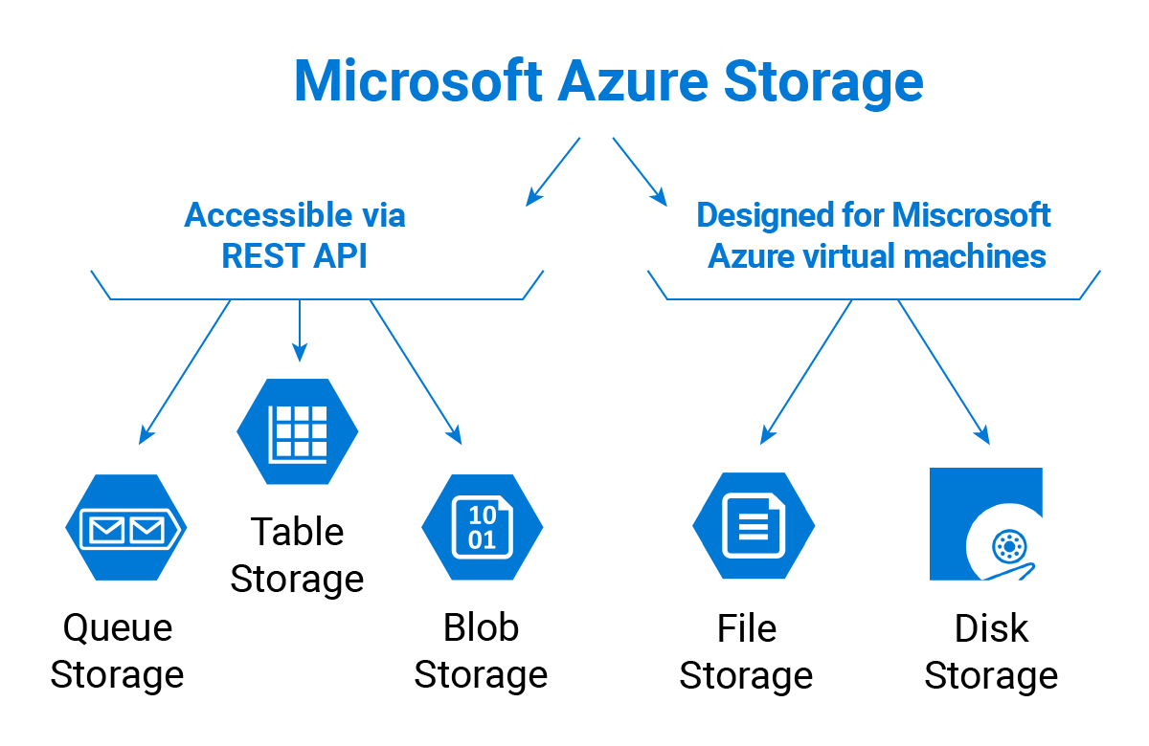

### **1. Azure Blob Storage (Object Storage)**

* Used to store **large amounts of unstructured data** (text, images, videos, backups).
* Supports **three access tiers**:
  + **Hot**: Frequently accessed data.
  + **Cool**: Infrequently accessed data.
  + **Archive**: Rarely accessed, long-term storage.
* Data is stored as **Blobs** (Binary Large Objects) in **containers**.

🔹 **Use Cases**: Media streaming, backups, big data, logs, disaster recovery.

### **2. Azure File Storage (Managed File Shares)**

* Provides **serverless file shares** accessible via **SMB (Server Message Block)** and **NFS (Network File System)**.
* Supports **Azure File Sync**, allowing synchronization between on-premises and cloud storage.

🔹 **Use Cases**: Shared file systems for applications, data migration, cloud backups.

### **3. Azure Queue Storage (Message Queue)**

* Used for **asynchronous message processing** between application components.
* Messages can be up to **64 KB** in size and can be retained for **7 days**.

🔹 **Use Cases**: Decoupling microservices, job scheduling, event-driven processing.

### **4. Azure Table Storage (NoSQL Key-Value Store)**

* A **NoSQL** database for storing large amounts of **structured** data.
* Supports **schema-less** design, making it **highly scalable**.
* Queries can be performed using **OData protocol**.

🔹 **Use Cases**: Logging, IoT data storage, telemetry data.

### **5. Azure Disk Storage (Virtual Machine Storage)**

* Provides **high-performance, durable block storage** for Azure Virtual Machines.
* Types of disk storage:
  + **Standard HDD**: Low-cost storage for less critical workloads.
  + **Standard SSD**: Cost-effective, better performance than HDD.
  + **Premium SSD**: High-performance for mission-critical workloads.
  + **Ultra Disk**: Extremely high IOPS and low latency for intensive workloads.

🔹 **Use Cases**: Running databases, hosting applications, VM storage.

## ****Security and Compliance in Azure Storage****

* **Encryption**: Data is encrypted at rest and in transit.
* **Access Control**: Supports **Azure AD authentication** and **Shared Access Signatures (SAS)**.
* **Geo-Redundancy**: Data can be replicated across regions for **disaster recovery**.

## ****Conclusion****

Azure Storage is a **versatile and scalable** cloud storage solution catering to different needs, from object storage (Blob) to virtual machine disks (Disk Storage). By understanding the different storage options, businesses can optimize their cloud strategy for **performance, cost-efficiency, and security**.

Would you like a **real-world example** or a **hands-on guide** on using Azure Storage? 🚀